App Requirements Document: Mod Comms Proofing Tool

Date Created: 01/10/2025

Date Updated: 20/11/2025 – v5

Author: OLIVER UK / Steve O’Donoghue

Status: Draft

Application Requirements

1. Must Have
These are the non-negotiable, critical features required for the app to function and launch.

User Management & Authentication (P1)
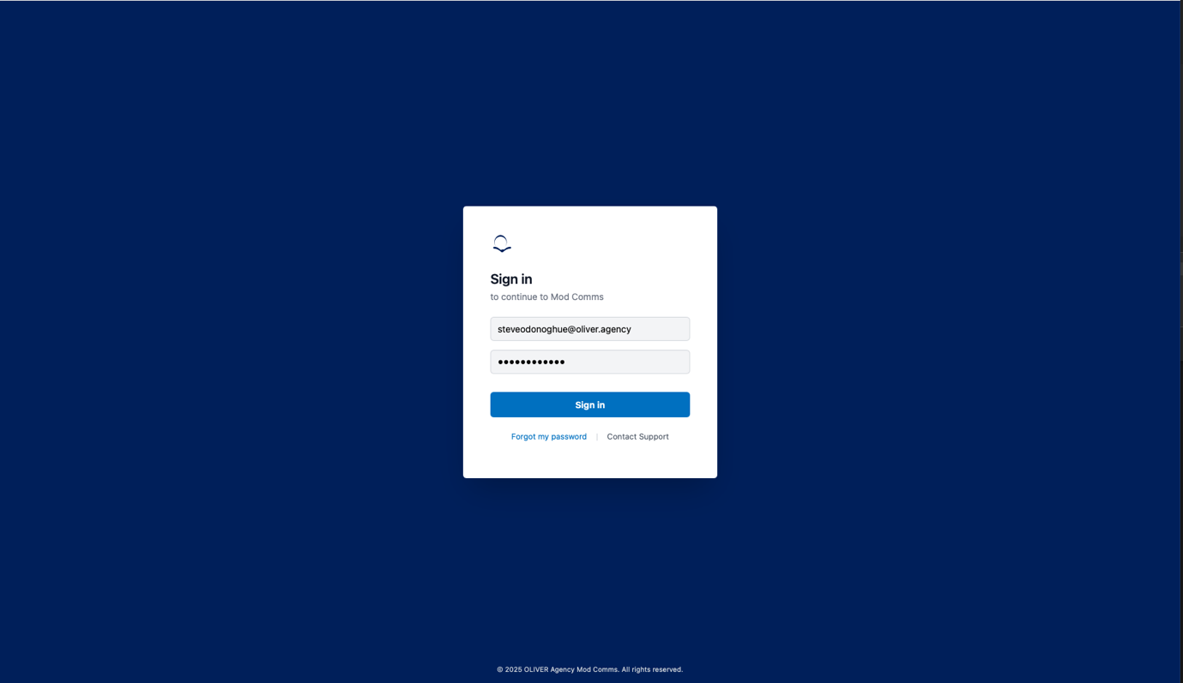
- User/access management: The app must integrate with the same O365/Azure/SSO platform already in place for the existing ‘CopyGenAI’ application to support seamless sign-on as part of users existing accounts.
- Login Screen: A sign-in screen must be presented to unauthenticated users, featuring:
  - An email address field.
  - A password field.
  - A "Sign in" button.
- Password Reset: The system must provide a "Forgot my password" link that allows users to have password reminder/reset notifications sent to them – this will be in-line with the Azure workflow, with the front end of the app enabling the basic Azure process through the CTA.
- Support Request: The login screen must include a "Contact Support" link. This link must allow a user to enter a message which is then submitted via email to the support team.
- User Roles & Permissions: The app must support at least two user roles, "Admin" and "Basic User," with different permissions as follows:
  - Admin: Can see all navigation options and all campaigns from all agencies.
  - Basic User: Sees a subset of navigation options (critically, "Campaigns") and can only see campaigns associated with their own agency.
Support ticket screen: (P2)
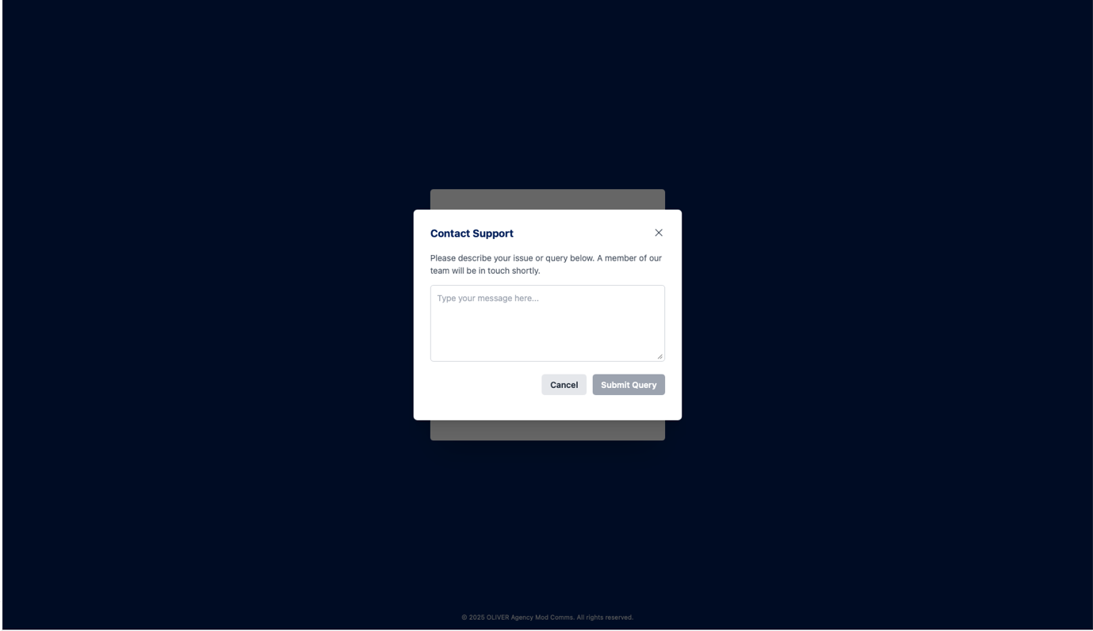

Core App Structure (P2)

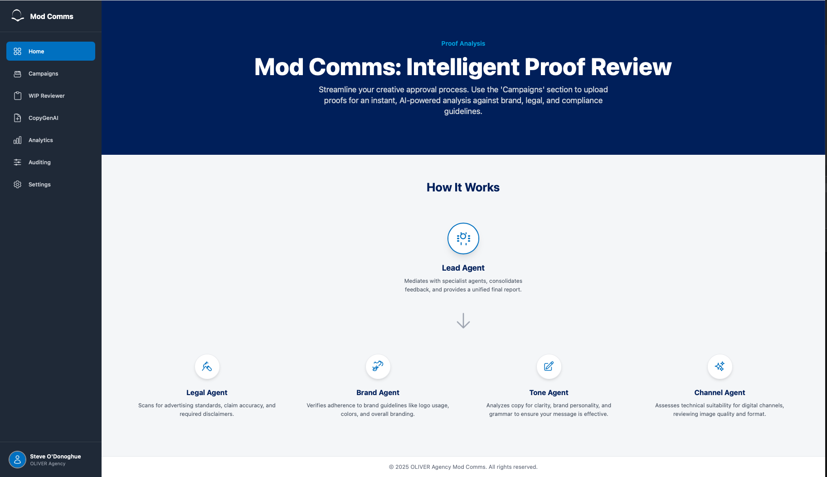
- Homepage: After logging in, the user must land on a "Home" page that explains how the tool works and details the available AI agents (e.g., Lead Agent, Legal Agent, Brand Agent, etc.).
- Main Navigation: A persistent vertical navigation bar must be present on the left side of the screen. Visibility is based on the user type and is as follows:
  - Basic user
    - Home
    - Campaigns
    - Analytics
    - Auditing
    - Settings
    - Profile (to log out)
  - Admin user
    - Home
    - Campaigns
    - Profile (to log out)

Profile screen:

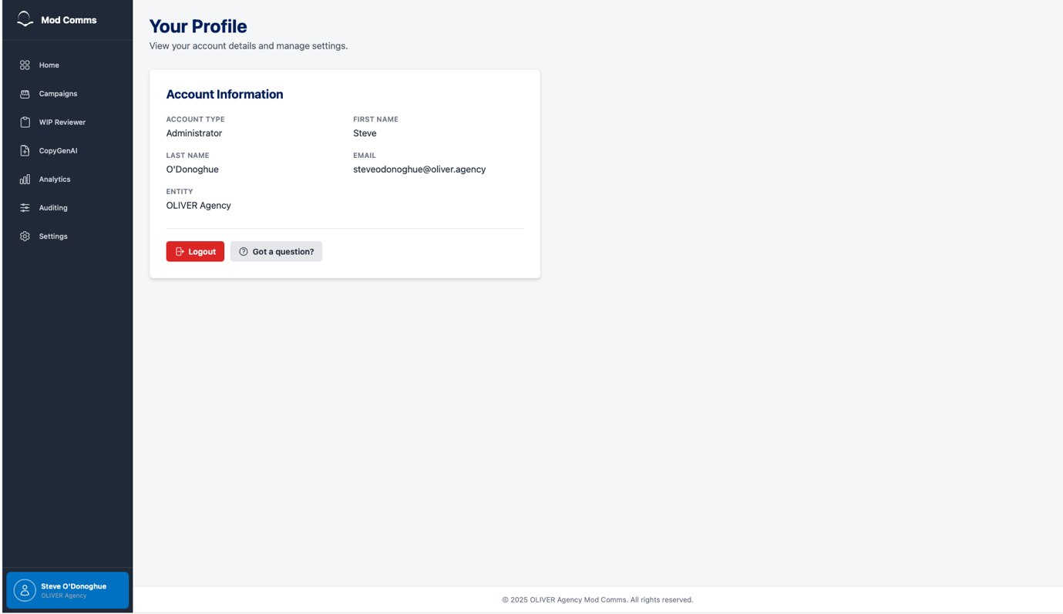

Campaigns (Top Level)

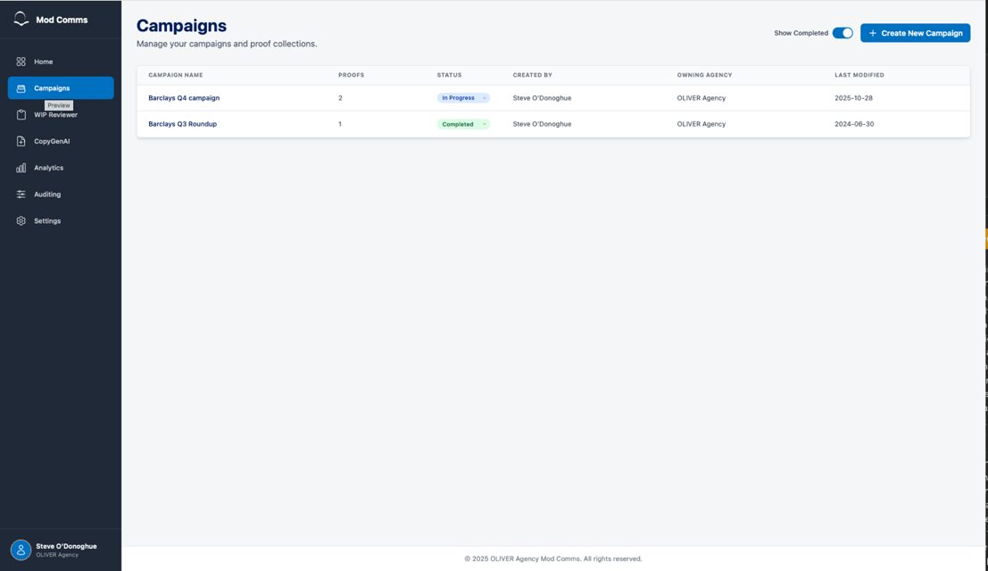

- Campaigns View: The "Campaigns" navigation item must lead to a top-level page that displays a user's accessible campaigns in a table.
- Campaign Table Columns: The campaign table must display the following columns: "CAMPAIGN NAME," "PROOFS" (a count of assets), "STATUS," "CREATED BY," "OWNING AGENCY," and "LAST MODIFIED".
- Manual Campaign Status: Users must be able to manually change a campaign's status between "In Progress" and "Completed".
- Show Completed toggle: Users must be able to hide/show campaigns which they have marked as completed using a toggle mechanic.
- Create New Campaign:
  - The page must feature a "+ Create New Campaign" button.
  - Clicking this button must open a pop-up modal.
  - This modal must require the user to enter a "Campaign Name," “Brand Guidelines” with a drop down showing two options “Barclays” and “Barclaycard”, "Campaign ID" (or a link to Workfront), and a "Client Lead".
  - The "Agency" and "Agency Lead" fields must be pre-filled and tied to the user's account.
  - Note: The selected “Guidelines” present a key decision to the user and for the app – as the selected value will determine the guidelines which the agents reference as part of the scoring/response.
Create new campaign screen:

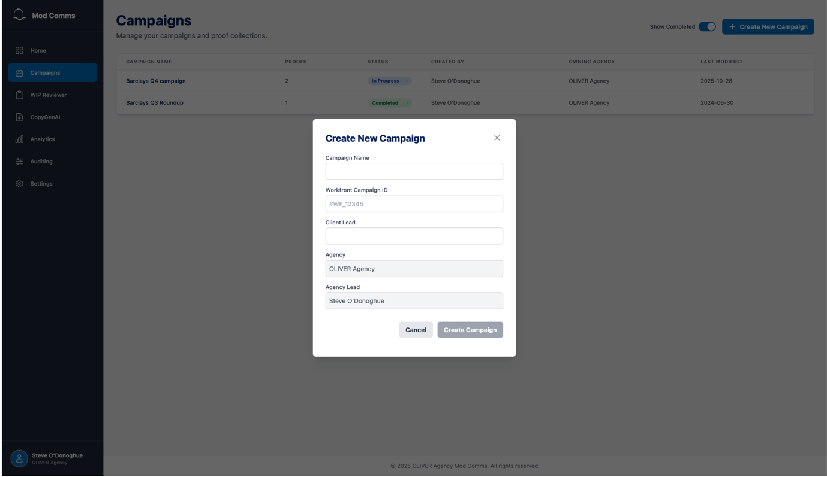

Proofs (Asset Level)

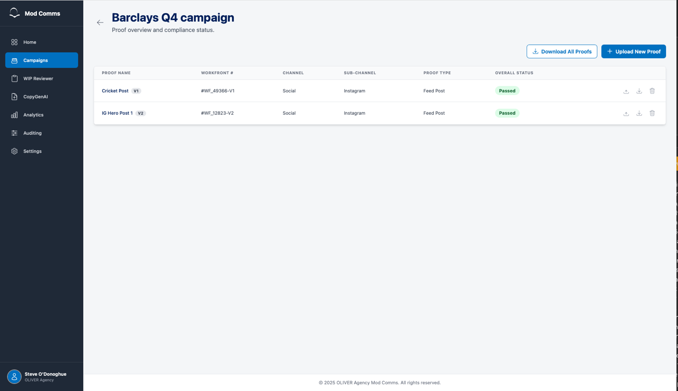
- Proofs View: Clicking on a campaign from the main list must navigate the user to the "Proofs" screen , which displays a table of all assets (proofs) uploaded to that campaign.
- Proofs Table Columns: The proofs table must display: "PROOF NAME" (with version number, e.g., "V1," "V2") , "WORKFRONT #," "CHANNEL," "SUB-CHANNEL," "PROOF TYPE," and "OVERALL STATUS".
- Proof Row Actions: Each row in the proofs table must have icons allowing the user to:
  - Upload a new version of that specific asset.
  - Download the asset.
  - Delete the asset.
- Upload New Proof:
  - The page must feature an "+ Upload New Proof" button.
  - This button must open a flow requiring the user to provide mandatory fields, including "Proof Name".
  - The user must select a "Channel" (e.g., Social).
  - Based on the Channel, the user must select a "Sub-Channel" (e.g., Instagram).
  - Based on the Sub-Channel, the user must select a "Proof Type" (e.g., Feed Post, Reel). This field's options must be dependent on the Sub-Channel selection.
  - The user must be able to select a file from their computer for upload.
  - The final "Upload and Analyse Proof" button must be disabled until all required fields are filled.
  - A matrix of the supported platforms, channels and asset types is included below:
#​ | Channel​ | Platform​ | Deliverable​ | Format​ | Spec​
1​ | Social​ | Meta​ | Static image​ | Storyboard .PDF​ | In-feed 1x1​
2​ |  |  |  |  | In-feed 4x5​
3​ |  |  |  |  | Reels static 9x16​
4​ |  |  |  |  | Stories Static 9x16​
5​ | Social​ | Meta​ | Video​ | Storyboard .PDF​ | In-feed 1x1​
6​ |  |  |  |  | 9x16 reels​
7​ |  |  |  |  | 9x16 stories​
8​ | Social​ | YouTube - (online video)​ | Video​ | Storyboard .PDF​ | 1x1​
9​ |  |  |  |  | 16x9​
10​ | Social​ | Google - Perormance Max​ | Video​ | Storyboard .PDF​ | 1x1​
11​ |  |  |  |  | 9x16​
12​ |  |  |  |  | 16x9​
13​ | Social​ | Google - Perormance Max​ | Static image​ | Storyboard .PDF​ | 1080x1080​
14​ |  |  |  |  | 4x5 (1080x1350)​
15​ |  |  |  |  | 1.91x1 (1200x628)​
16​ |  |  |  |  | Logo 1x1 (1080x1080)​
17​ | Display​ | Online - General​ | Banner​ | Storyboard .PDF​  ​ | 300x600​
18​ | Display​ | Online - General​ | Banner​ | Storyboard .PDF​  ​ | 160x600​
19​ | Display​ | Online - General​ | Banner​ | Storyboard .PDF​  ​ | 970x250​
21​ | Display​ | Online - General​ | Banner​ | Storyboard .PDF​  ​ | 300x250​
22​ | .co.uk Banner​ | Barclays​ | Web Banner Design + Static Image​ | Storyboard .PDF​ | 720x540​
23​ | .co.uk Banner​ | Barclaycard​ | Web Banner Design + Static Image​ | Storyboard .PDF​ | 1316x740​
24​ | Copy​ | AD Copy ​ | Copy Document​ | PDF or word doc​ | ​N/A

- Analysis Progress: After uploading, the system must show a progress or loading indicator while the asset is being analysed by the various agents.
Upload new proof screen:

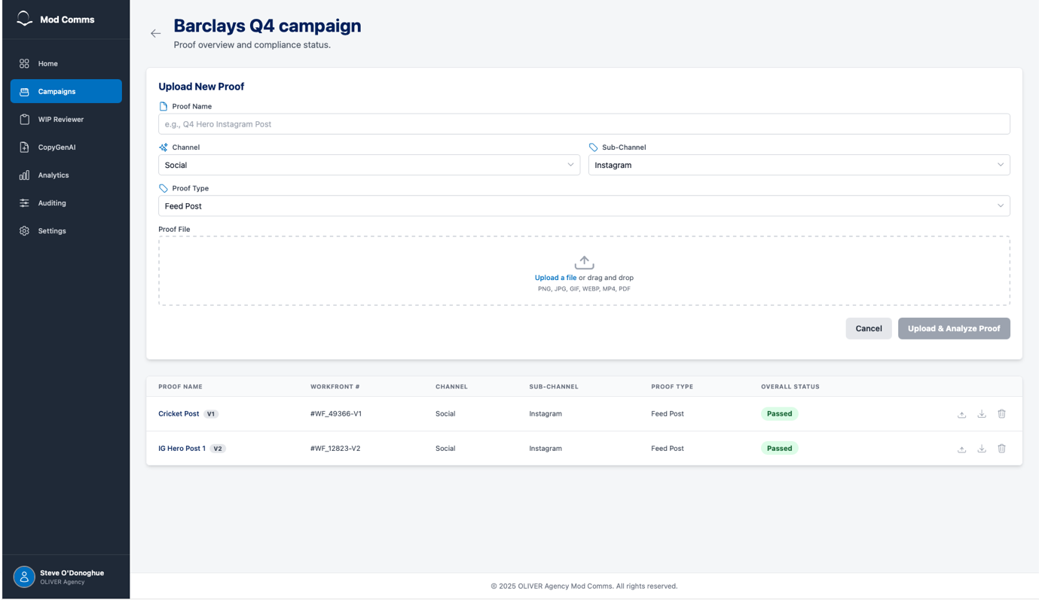

Asset Detail & Analysis View (P1)

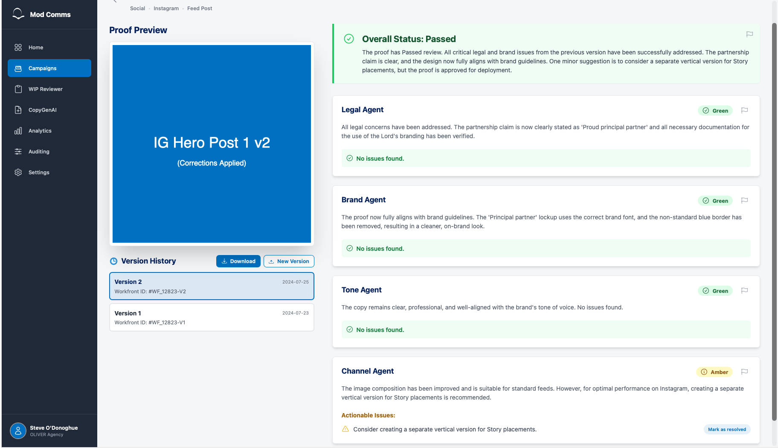
- Detail View: Clicking a specific proof from the proofs table must open the asset detail view.
- Layout: This screen must have a two-column layout:
  - Left Column: Contains the "Proof Preview" , asset metadata (Title, Proof Type, Channel, Sub-Channel) , and a "Version History" section.
  - Right Column: Contains the full analysis and feedback from all agents.
- Version History: The "Version History" section must list all uploaded versions (e.g., "Version 1") and provide a "Download" button for each specific version. This page must also have an "+ New Version" button.
- Agent Feedback:
  - The right column must display an "Overall Status" (e.g., Passed) at the top.
  - It must also display detailed feedback sections for each individual agent (e.g., Legal Agent, Brand Agent, Tone Agent, Channel Agent).
  - Agents must be able to return a "Pass" (Green), "Amber" (with issues), or "Fail" (Red) status.
  - If an asset is un-assessable, agents must return an "Error" status.
- Core Analysis Logic: The "Lead Agent" must mediate the feedback from all sub-agents to determine the final "Overall Status". The system must allow an asset to "Pass" overall, even if a sub-agent finds "Amber" issues.
  - The application must allow for agent weighting and logic to be fine-tuned as part of QA/UAT testing phases
  - Mediator agent RAG status definitions for MVP:
    - Green – All agents pass the upload, up to 1 Actionable Issue/Amber issue from each agent allowed. Actionable Issue/Amber from the Legal Agent triggers ‘Amber’ overall from the mediator
    - Amber – Any agent returning more than one actionable issue, or any actionable issues returned from the Legal agent
    - Red – Failure from any of the sub-agents
- Issue Resolution: Users must have the ability to manually override an agent's finding.
  - There must be a "Mark as resolved" button for actionable issues.
  - When clicked, the user must be able to submit a resolution note.
  - Upon submission, the issue must be visually struck-through and marked as green.
  - Re-open Resolved Issues: The ability for a user to "reopen" an issue that they previously marked as resolved.
- Flag Agent Feedback: A "flag" icon next to each agent's analysis that allows a user to report incorrect or problematic feedback (e.g., "This is agreed with legal") to the admin/support team.

Flag incorrect analysis screen:
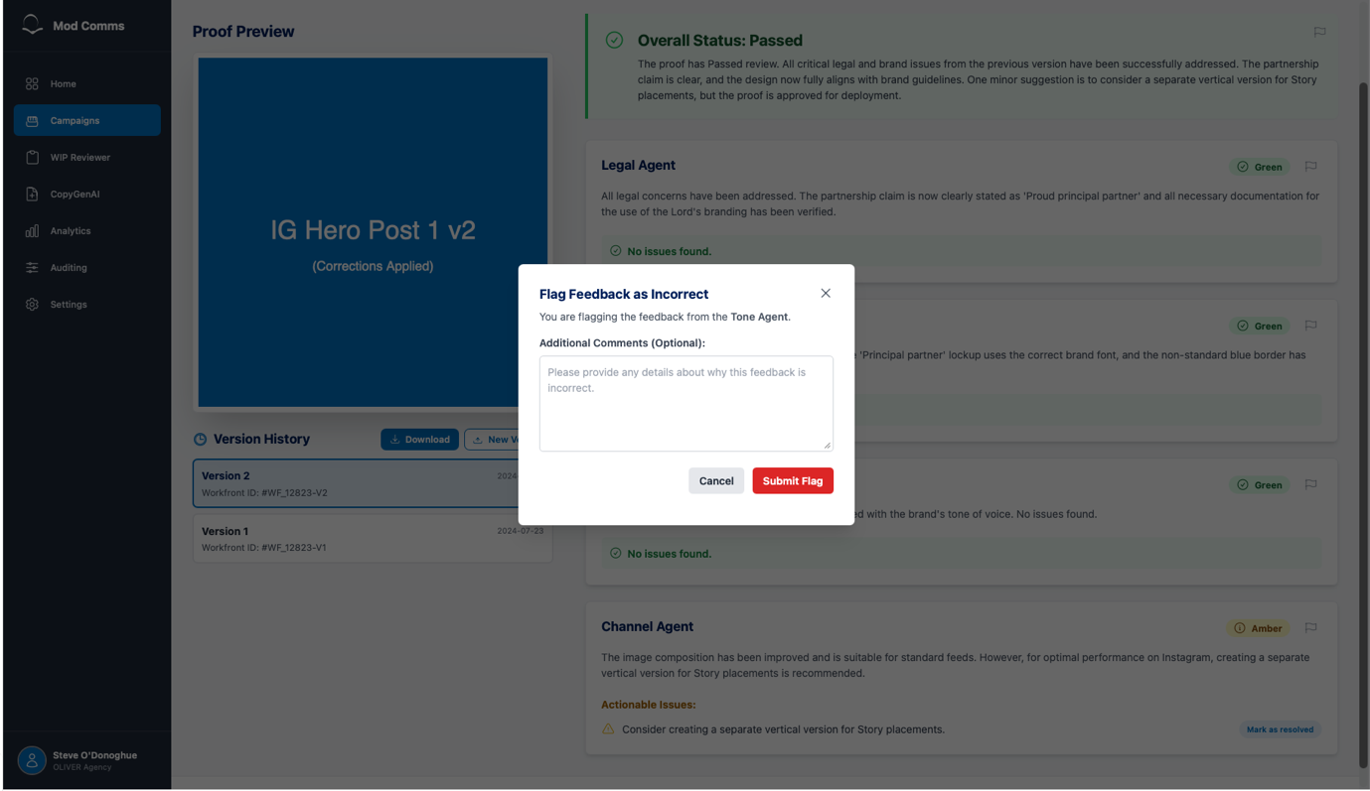
Resolve issue screen:
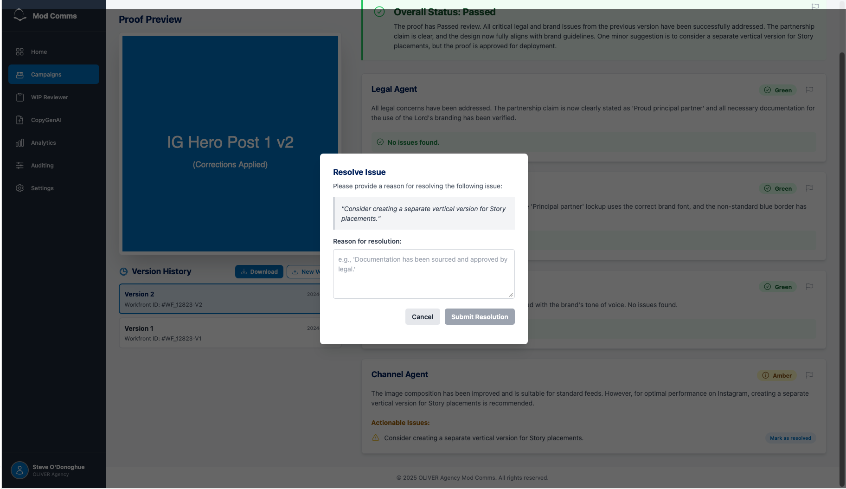
Error with uploaded asset screens:
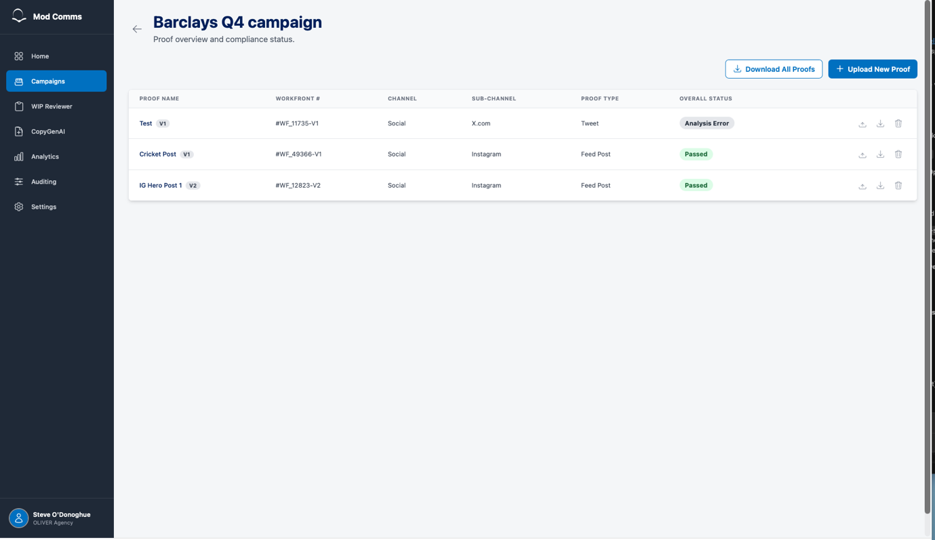
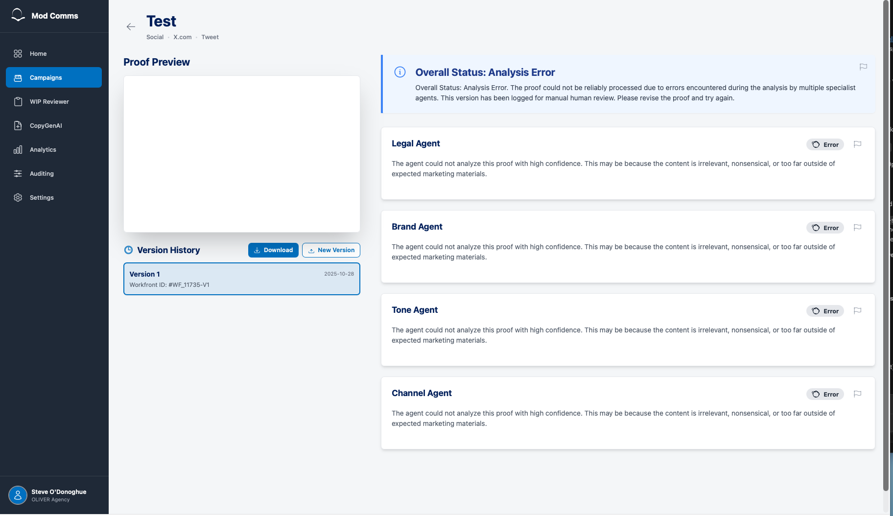

‘Financial Promotion’ Handling
Following a review with the legal team, requirements were shared around the tools handling of advertising assets which reference ‘Financial Promotion’. An example of these is included below:
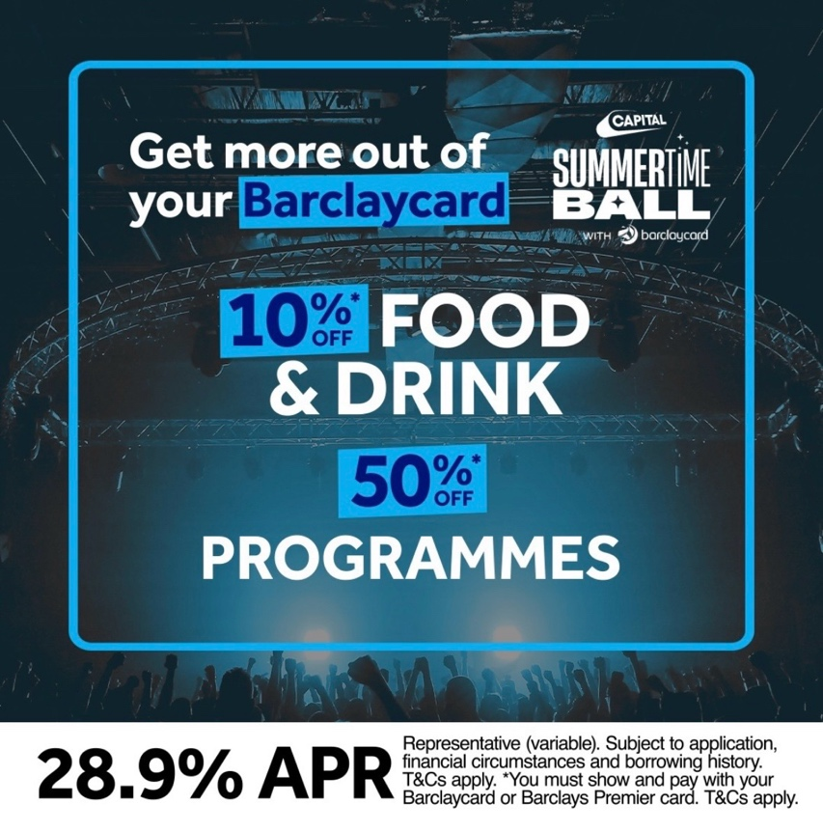
When a user uploads an asset the app must perform a check to determine if ‘financial promotion’ is present – in these cases the user will need to ensure a formal legal review is undertaken. Full analysis and assessment must still complete but the app must clearly highlight the status to the user. Requirements and examples are detailed below:
- Financial Promotion Handling:
  - If a proof is flagged as "Requires Manual Legal Review", the PDF must prominently display this status and include the specific reason provided.
  - Clear visual distinction/labelling must be present on the asset table (shown below)
  - Clear visual distinction/labelling must be present on the result page for the given asset (shown below)

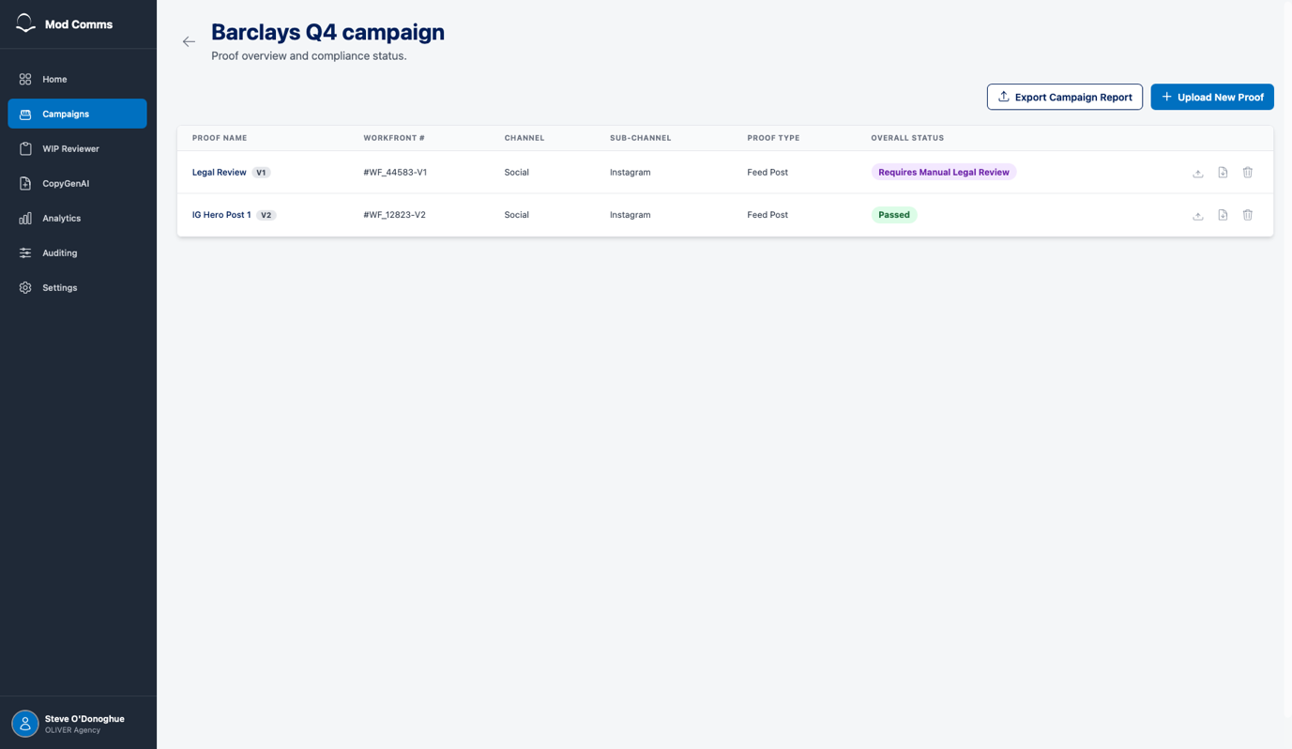
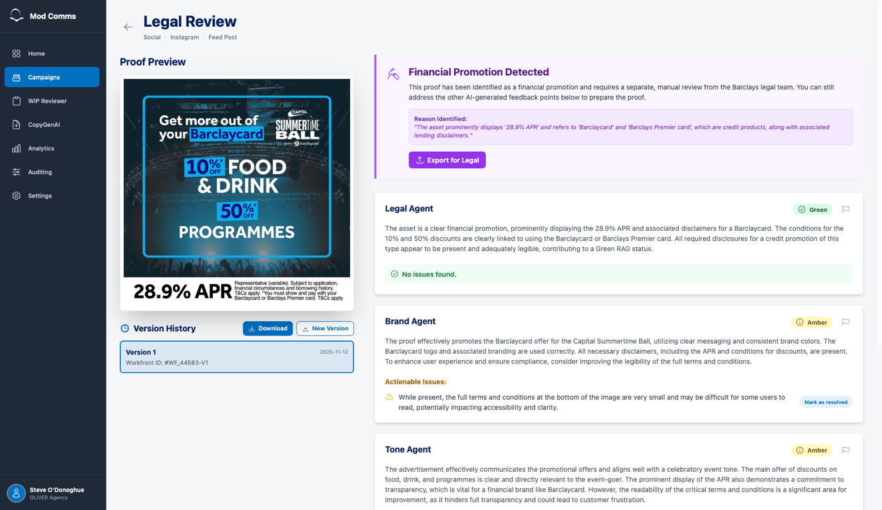

Agent weighting/decision logic via the moderator agent:

Export functionality: (P1)
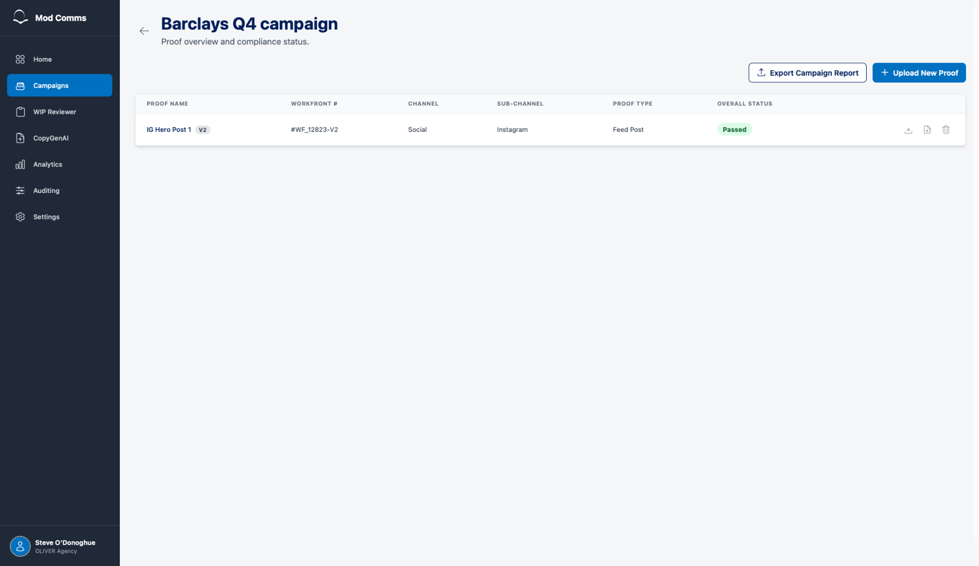
- Single Proof PDF Export: (P1)
  - The system must provide a mechanism for the user to export a detailed feedback report for a single proof into a downloadable PDF file – as an icon included against the asset row within the ‘assets table’
- Campaign PDF Export: (P2)
  - The system must provide a mechanism for the user to export a consolidated feedback report for all completed proofs within a campaign into a single downloadable PDF file.
- Export Format
  - Report Cover Page: The exported PDF must include a cover page containing:
    - Barclays and OLIVER Agency branding.
    - A clear title (e.g., "AI Compliance & Brand Report").
    - The name of the campaign being reported on.
    - The name of the specific proof (for single proof exports).
    - The date the report was generated.
  - Report Content - Proof Details: Each proof section within the PDF must include:
    - The proof's name and version number.
    - A visual preview of the proof.
    - The overall summary and final status from the Lead Agent. (P2)
  - Report Content - Agent Feedback: Each proof section must display the detailed analysis from all specialist agents, including:
    - The agent's name.
    - The RAG (Red, Amber, Green) status.
    - The agent's full feedback text.
    - A bulleted list of any specific, actionable issues identified.
- Should Haves
  - Visual Feedback on Export: The UI should provide clear visual feedback to the user while a PDF is being generated, such as a loading spinner, and the export buttons should be disabled during this process.
  - Professional Layout: The PDF report should have a clean, well-organized, and professional layout suitable for sharing with clients and internal stakeholders.
  - Campaign Report Table of Contents: The campaign-level PDF report should begin with a Table of Contents that lists all the proofs included in the document for easier navigation.
  - Clipboard Success Indicator: The "Export for Legal" feature should provide temporary visual confirmation that the text has been successfully copied (e.g., by changing the button text to "Copied to Clipboard!").
  - Meaningful Filenames: The downloaded PDF files should have logical, descriptive filenames, such as Campaign_Name_Report.pdf.

Analytics Screen (P2)

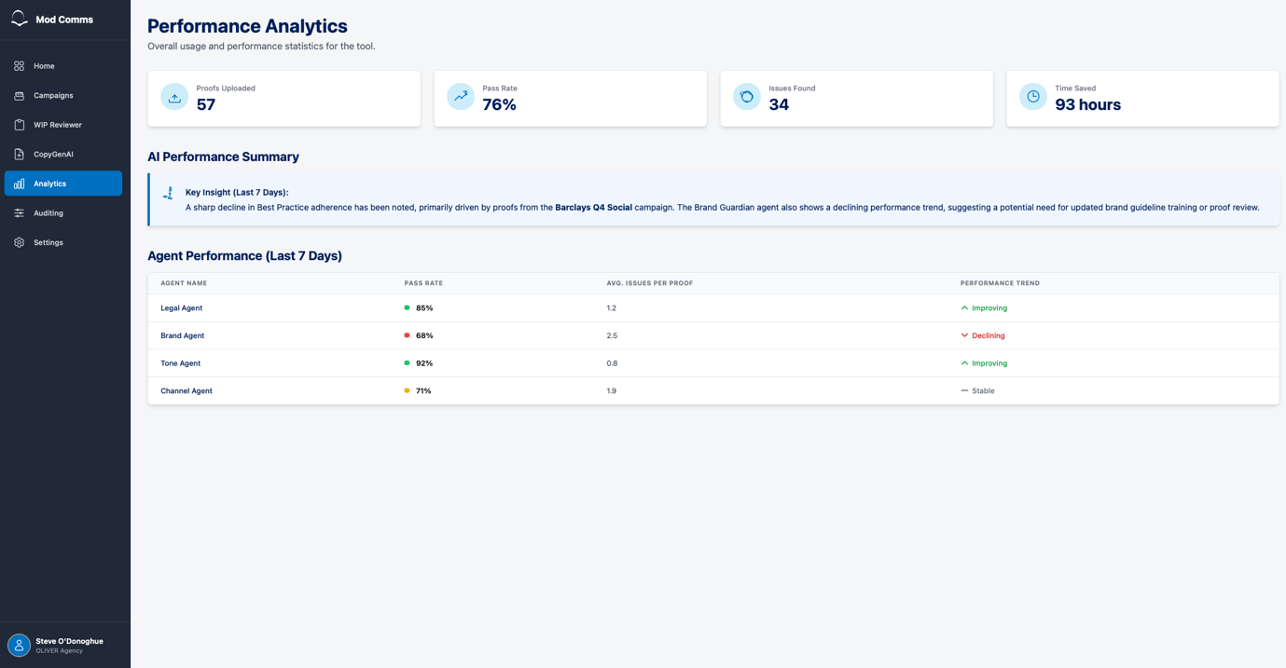
- Analytics Page Access: The "Analytics" section must be accessible from the main sidebar but must only be visible to "Admin" users. It must not be visible to "Basic" users
- Overall Performance KPIs: The Analytics page must display a top-level summary of overall statistics.
- KPI Metrics: This summary must include the following all-time metrics:
  - "Proofs Uploaded": A total count of all proofs uploaded to the tool.
  - "Pass Rate": A percentage calculation of assets that have passed versus failed.
  - "Issues Found": A total count of all issues identified by the AI agents.
  - "Time Saved": A metric presented in hours.
    - "Time Saved" Calculation: This metric must be calculated based on the number of new versions created from AI feedback, representing the time saved by not having to involve the legal team for those revisions.

Auditing Screen (P2)

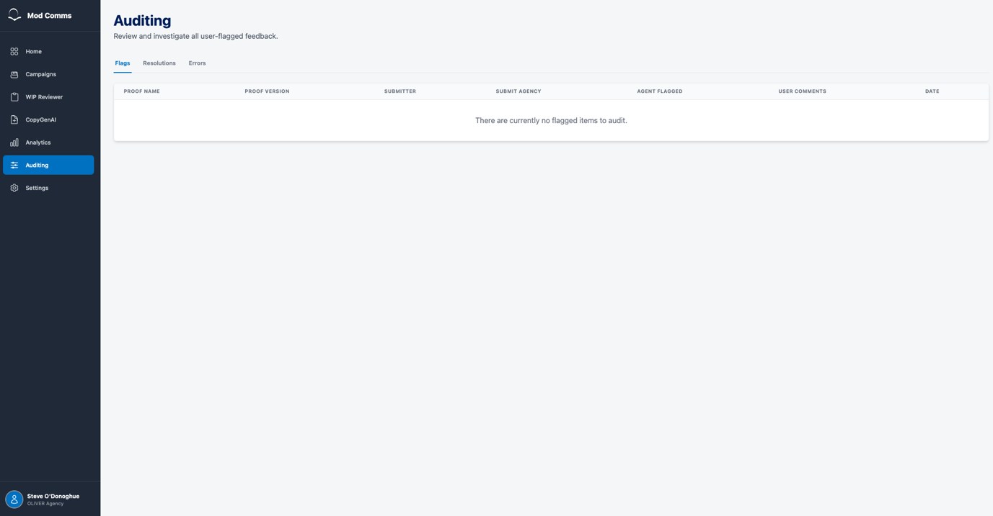
- Auditing Page Access: The "Auditing" section must be accessible from the main sidebar and must only be available to "Admin" users.
- Tabbed Navigation: The Auditing screen must be organized into three distinct tabs: "Flags," "Resolutions," and "Errors".
- "Flags" Tab:
  - This tab must capture and display all items that users have "flagged" within the tool.
  - It must contain a table with the following columns: "PROOF NAME," "PROOF VERSION," "SUBMITTER," "SUBMIT AGENCY," "AGENT FLAGGED," "USER COMMENTS," and "DATE".
- "Resolutions" Tab:
  - This tab must allow admins to review all issues that users have marked as "resolved".
  - It must contain a table with the following columns: "PROOF NAME," "PROOF VERSION," "SUBMITTER," "SUBMIT AGENCY," "AGENT," "AGENT ISSUE" (the issue found by the agent), "USER COMMENTS" (the user's resolution note), and "DATE".
- "Errors" Tab:
  - This tab must log and display all assets that could not be assessed because the AI agents returned an error.
  - It must contain a table with the following columns: "PROOF NAME," "PROOF VERSION," "SUBMITTER," "SUBMIT AGENCY," "ERROR SUMMARY" (the error message shown to the user), and "DATE".

Settings Screen (P1)

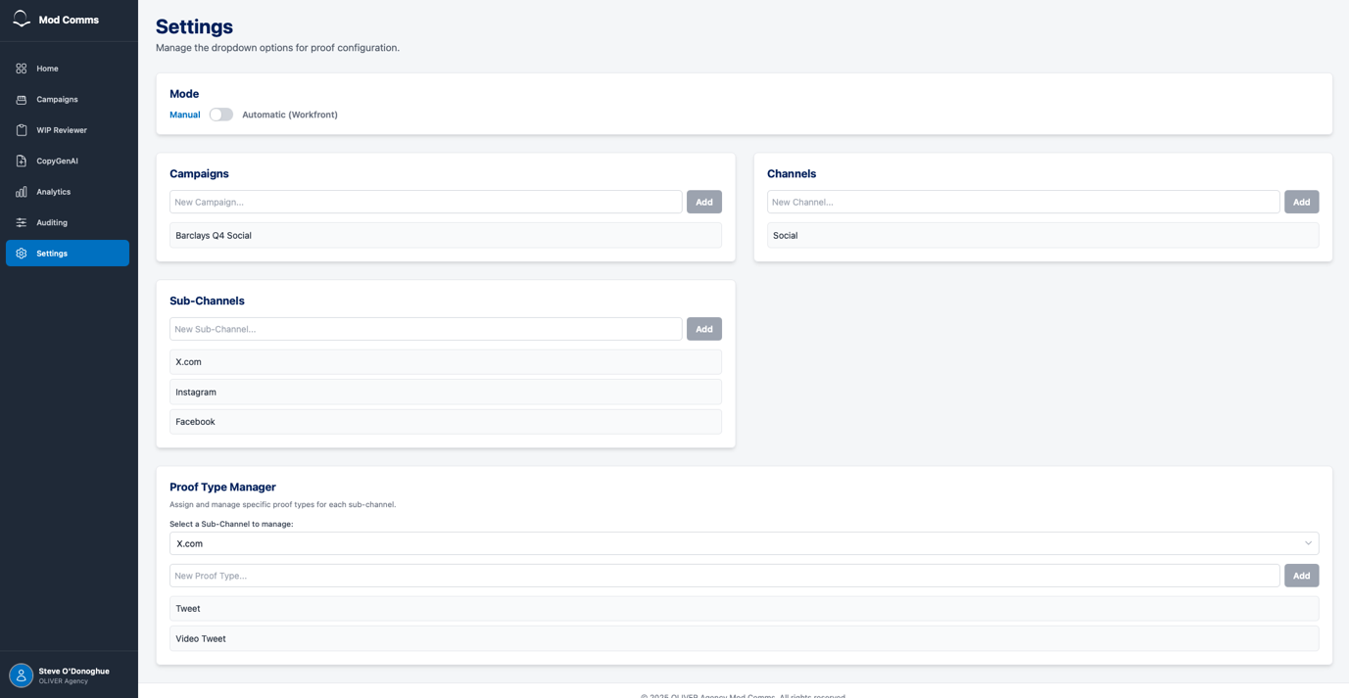
- Settings Page Access: The "Settings" section must be accessible from the main sidebar and must only be available to "Admin" users.
- Dropdown Configuration: The Settings page must allow admins to manage the selectable options available to basic users during campaign setup and asset upload.
- Campaign Management: Admins must be able to add new campaign names to the list via a text field and "Add" button.
- Channel Management: Admins must be able to add new channel names (e.g., "Social") to the list via a text field and "Add" button.
- Sub-Channel Management: Admins must be able to add new sub-channel names (e.g., "Instagram," "Facebook") to the list via a text field and "Add" button.
- Delete Functionality: For Campaigns, Channels, and Sub-Channels, admins must be able to delete an existing item from the list by hovering over it to reveal a delete button.
- Proof Type Manager:
  - The page must have a "Proof Type Manager" section to manage proof types, which are dependent on sub-channels.
  - The admin must first select a "Sub-Channel" from a dropdown menu.
  - Upon selection, the system must display the proof types associated with that sub-channel.
  - The admin must be able to add (e.g., "Feed Post," "Tweet") and delete proof types for the selected sub-channel.
- Dropdown Sync: Changes made in the Settings page must be reflected in the dropdowns shown to basic users during their workflows.
Staging and Production Environments (P1)

2. Should Have
These are important features that add significant value but are not critical for the initial launch.
- Analytics Screen
  - AI Key Insight Summary: The Analytics page should feature an "AI Performance Summary" section. This should be an AI-generated text summary that assesses weekly performance, notes trends, and provides insights (e.g., "sharp decline in best practice... suggesting a need for updated brand guideline training").
  - Agent Performance Table: The Analytics page should include a table titled "Agent Performance (Last 7 Days)".
  - Agent Table Contents: This table should list all available agents (e.g., "Legal Agent," "Brand Agent") and display the following metrics for each:
    - "Pass Rate": The agent's pass rate as a percentage.
    - "Avg. Issues Per Proof": The average number of issues that agent finds per uploaded proof.
  - Pass Rate Traffic Lights: The "Pass Rate" column in the agent table should use a traffic light color-coding system:
    - Green: for rates above 70%.
    - Yellow: for rates between 40% and 70%.
    - Red: for rates below 40%.

3. Could Have
These are desirable, "nice-to-have" features that can be added if time and resources permit.
- Global
  - SSO Integration: Integration with Office 365 or Azure for single sign-on (SSO) and user management, as an alternative to the internal backend user store. (P1)
  - Expanded Modules: Future development of the "WIP Reviewer," "CopyGenAI," sections visible in the main navigation.
- Analytics Screen
  - Agent Performance Trend: The "Agent Performance" table could include a "Performance Trend" column. This column would analyze the agent's pass rate week-on-week and display a status like "Improving," "Declining," or "Stable".

4. Won't Have (This Release)
These are features explicitly mentioned as out-of-scope for this version to manage expectations.
- Automatic Status Sync: There will be no automatic synchronization between the app and Workfront to pull project status. The "Completed" or "In Progress" status must be maintained manually within this application.
- Workfront Link: Allowing the "Campaign ID" field to accept a direct URL link to a Workfront project, not just a text-based ID.
- Expanded Modules: Future development of the "WIP Reviewer," "CopyGenAI," sections visible in the main navigation.
- Settings Screen – “Configuration Mode” - the Settings page could include a "Mode" toggle at the top, allowing an admin to switch the app's configuration source between "Manual" (using the settings on this page) and "Automatic (Workfront)".

